Workshop- QoS Concepts
By configuring the quality of service (QoS), you can provide preferential treatment to specific types of traffic at the expense of other traffic types. Without QoS, the device offers best-effort service for each packet, regardless of the packet contents or size. The device sends the packets without any assurance of reliability, delay bounds, or throughput.
Topology
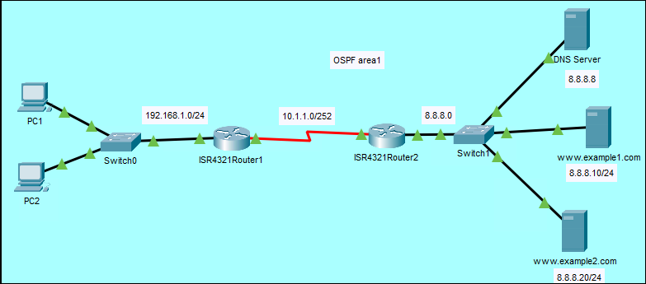

Initial network configuration
- IP addresses on PCs, servers and routers
- Configure routers’ interfaces
- Routing on the routers using OSPF, refer to last week’s workshop how to do this if you need to
- Configure DNS record to match the web servers
- On the serial link configure a bandwidth of 1Mbps
Router1(config-if)#bandwidth 1000
Configure the QoS with the following requirements
On Router 1
Match traffic
Voice using NBAR (rtp)
Set DSCP to EF
HTTP using NBAR (http)
Set DSCP to AF31
ICMP using NBAR (icmp)
Set DSCP to AF11
Bind outbound on serial interface
Voice should get a priority bandwidth of 70% of the available bandwidth
HTTP should get minimum bandwidth of 60% of the remaining bandwidth
ICMP should get minimum bandwidth of 30% of the remaining bandwidth

Create class maps to classify traffic with NBAR

Router1(config)#class-map voice
Router1(config-cmap)#match protocol rtp
Router1(config-cmap)#exit
Router1(config)#class-map http
Router1(config-cmap)#match protocol http
Router1(config-cmap)#exit
Router1(config)#class-map icmp
Router1(config-cmap)#mat
Router1(config-cmap)#match protocol icmp
Router1(config-cmap)#

Create QoS policies to match the traffic classes created.
Create a policy named QOSMark (or any name of your choice) and inside the policy set some rules for the different classes

Router1(config)#policy-map QOSMark
Router1(config-pmap)#class voice
Router1(config-pmap-c)#set ip dscp ?

Explore the different values with their binary equivalent. Set the DSCP to EF and provide a priority for Voice traffic at 70% of the available bandwidth

Router1(config-pmap-c)#set ip dscp ef
Router1(config-pmap-c)#priority 70

Set the parameters for the other two traffic, HTTP and ICMP

Router1(config)#policy-map QOSMark
Router1(config-pmap)#class http
Router1(config-pmap-c)#set ip dscp af31
Router1(config-pmap-c)#bandwidth remaining percent 60

Router1(config-pmap)#class icmp
Router1(config-pmap-c)#set ip dscp af11
Router1(config-pmap-c)#bandwidth remaining percent 30

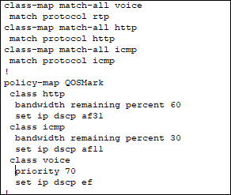

The next step is to bind the policy to the interface on the outbound direction and match it to the QoS policy created

Router1(config)#int s0/1/0
Router1(config-if)#service-policy output QoSMark

We now need to do something similar on Router 2 and configure QoS using DSCP.

Match traffic
Voice traffic using DSCP EF
Set IP precedence to 5
HTTP traffic using DSCP AF31
Set IP precedence to 3
ICMP traffic using DSCP AF11
Set IP precedence to 0
Bind inbound on serial interface

Create the classes and assign DSCP values, you are not using NBAR

Router2(config)#class-map voice
Router2(config-cmap)#match ip dscp EF
Router2(config-cmap)#exit
Router2(config)#class-map http
Router2(config-cmap)#match ip dscp af31
Router2(config-cmap)#exit
Router2(config)#class-map icmp
Router2(config-cmap)#match ip dscp af11
Router2(config-cmap)#

We are going to read the DSCP values on the packets received on the serial interface and remark the DSCP values

Create a new policy on Router 2 and call it QoSRemark (or any other name of your choice)

Router2(config)#policy-map QoSRemark
Router2(config-pmap)#class voice
Router2(config-pmap-c)#set precedence ?

Explore the options. Note you can use the numeric values or the word. You can use the word critical or a value of 5

Router2(config-pmap-c)#set precedence critical
Router2(config-pmap-c)#exit
Router2(config-pmap)#class http
Router2(config-pmap-c)#set precedence flash
Router2(config-pmap-c)#exit
Router2(config-pmap)#class icmp
Router2(config-pmap-c)#set precedence routine

Check your configuration to see if you have the following settings:

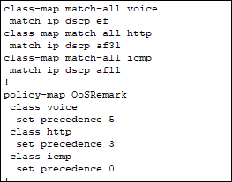

Next bound the policy to the serial interface
Router2(config)#int s0/1/0
Router2(config-if)#service-policy input QoSRemark

Verify that settings are working as expected

Router1#show policy-map

What’s the summary of your QoS Settings?

Look at the statistics on the interface

Router1#show policy-map interface s0/1/0

Are there any matches for Voice, HTTP or ICMP traffic? Explain

Switch to simulation mode

Ping from PC1 to www.example1.com
Explore the DSCP values at the both sides of the two routers. Do they match your expected values in the settings?
Open a browser on PC2 and access www.example2.com. Observer the QoS values for HTTP traffic.

